# Section 3.2: The Derivative as a Function

## Derivative Functions

The derivative function gives the derivative of a function at each point in the domain of the original function for which the derivative is defined.

Let $f$ be a function. The **derivative function**, denoted by $f^{'}$, is the function whose domain consists of those values of $x$ such that the following limit exists:

$f^{'}\left(x\right)=\lim_{h→0}{\frac{f\left(x+h\right)-f(x)}{h}}$.

A function $f(x)$ is said to be **differentiable at $a$**  if $f^{'}(a)$ exists. More generally, a function is said to be differentiable on $S$ if it is differentiable at every point in an open set $S$, and a **differentiable function** is one in which $f^{'}(x)$ exists on its domain.

Media: Watch these [video](https://youtu.be/BRm2L2a9BTs)1 and [video2](https://youtu.be/1a9yyxvSfso) examples on using the definitions of the derivative.

Examples: Find the derivative of each function.

$f\left(x\right)=\sqrt{x}$

$f\left(x\right)=x^{2}-2x$

1. Suppose temperature $T$ in degrees Fahrenheit at a height $x$ in feet above the ground is given by $y=T(x)$.
   1. Give a physical interpretation, with units, of $T^{'}(x)$.
   2. If we know that $T^{'}\left(1000\right)=-0.1$, explain the physical meaning.

Note: There are variety of different notations to express the derivative of a function. For instance, if the function is expressed in the form $y=x^{2}-2x$, the derivative can be written as $y^{'}=2x-2$ or $\frac{dy}{dx}=2x-2$. The same information can be conveyed by writing $\frac{d}{dx}\left(x^{2}-2x\right)=2x-2$. Thus, for the function $y=f(x)$, each of the following notations represents the derivative of $f(x)$:

$$f^{'}\left(x\right), \frac{dy}{dx}, y^{'}, \frac{d}{dx}\left(f(x)\right)$$

## Graphing a Derivative

The graph of the original function and the derivative function are related. Given both, we would expect to see a correspondence between the graphs of these two functions, since $f^{'}(x)$ gives the rate of change of a function $f(x)$ (or the slope of the tangent line to $f(x)$).

For example, if $f\left(x\right)=x^{2}-2x, f^{'}\left(x\right)=2x-2$. The graphs of these functions are shown below.

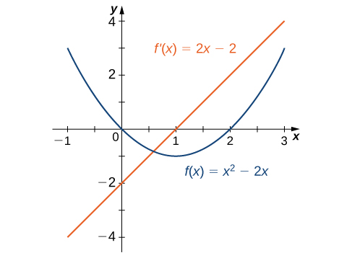

Note that the derivative $f^{'}\left(x\right)<0$ where the function $f(x)$ is decreasing and $f^{'}\left(x\right)>0$ where the function $f(x)$ is increasing. The derivative is zero where the function has a horizontal tangent.

Media: Watch this [video](https://youtu.be/Kz_reJgi_Rg) example on graphing the derivative of a function.

Examples

1. Use the following graph of $f(x)$ to sketch a graph of $f^{'}(x)$.

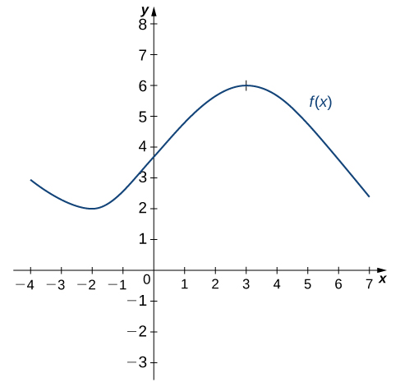

1. Sketch the graph of $f\left(x\right)=x^{2}-4$. On what interval is the graph of $f^{'}\left(x\right)$ above the $x$-axis?

## Derivatives and Continuity

After graphing the derivative, you can examine the behavior of these graphs.

**Differentiability Implies Continuity**

Let $f(x)$ be a function and $a$ be in its domain. If $f(x)$ is differentiable at $a$, then $f$ is continuous at $a$.

Note: The reverse is not true. **Continuity does not imply differentiability.**

1. If a function is not continuous, it cannot be differentiable, since every differentiable function must be continuous. However, if a function is continuous, it may still fail to be differentiable.
2. Functions that have a “sharp corner” or are “not smooth” at a point can be continuous but not differentiable. For instance, the function $f\left(x\right)=\left|x\right|$ fails to be differentiable at $0$ because the limit of the slopes of the tangent lines on the left and right are not the same (see figure below).

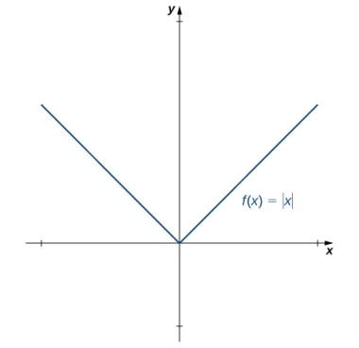

1. A function can fail to be differentiable at a point where there is a vertical tangent line, as shown in the graph of $f\left(x\right)=\sqrt[3]{x}$.

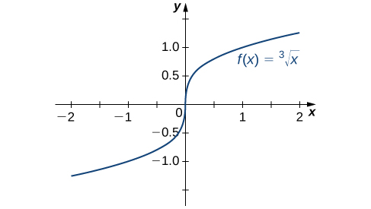

1. A function may fail to be differentiable at a point in more complicated ways as well. For instance, the function $f\left(x\right)=\left\{\begin{matrix}x\sin\left(\frac{1}{x}\right) if x≠0 \\ 0 if x=0\end{matrix}\right.$ has a derivative that exhibits interesting behavior at $0$. The limit does not exist, essentially because the slopes of the secant lines continuously change direction as they approach zero.

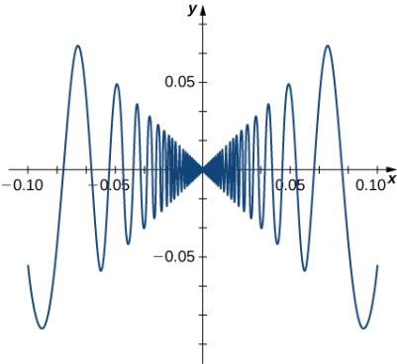

Media: Watch this [video](https://youtu.be/_vimObBaJxI) example on continuity and differentiability.

Examples

1. For the graph below,
   1. Determine for which values of $x=a$ the $\lim_{x→a}{f(x)}$ exists but $f$ is not continuous at $x=a$.
   2. Determine for which values of $x=a$ the function is continuous but not differentiable at $x=a$

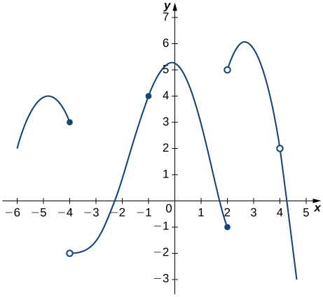

Media: Watch this [video](https://youtu.be/Ztt_AMsnn0g) example on graphing a function with given properties.

1. Sketch the graph of a function $y=f(x)$ with all of the following properties:
   1. $f^{'}\left(x\right)>0$ for $-2≤x<1$
 $f^{'}\left(2\right)=0$

 $f^{'}\left(x\right)>0$ 2. for $x>2$
   3. $f\left(2\right)=2$ and $f\left(0\right)=1$
   4. $\lim_{x→-∞}{f(x)}=0$ and $\lim_{x→∞}{f(x)}=∞$
   5. $f^{'}(1)$ does not exist.

## Higher-Order Derivatives

The derivative of a function is itself a function, so we can find the derivative of a derivative. For example, the derivative of a position function is the rate of change of position, or velocity. The derivative of velocity is the rate of change of velocity, which is acceleration. The new function obtained by differentiating the derivative is called the second derivative. We can continue to take derivatives to obtain the third derivative, fourth derivative, and so on. These are referred to as **higher-order derivatives.**

The notation for the higher-order derivatives of $y=f(x)$ can be expressed in any of the following forms:

$f^{''}\left(x\right),f^{'''}\left(x\right),f^{(4)}\left(x\right),…,f^{(n)}\left(x\right)$

$y^{''}\left(x\right),y^{'''}\left(x\right),y^{(4)}\left(x\right),…,y^{(n)}\left(x\right)$

$\frac{d^{2}y}{dx^{2}},\frac{d^{3}y}{dx^{3}},\frac{d^{4}y}{dx^{4}},…,\frac{d^{n}y}{dx^{n}}$

Media: Watch this [video](https://youtu.be/SIp6g-u-rkc) example on finding higher order derivatives.

Examples

1. For $f\left(x\right)=2x^{2}-3x+1$, find $f^{''}(x)$.
2. The position of a particle along a coordinate axis at time $t$ (in seconds) is given by $s\left(t\right)=3t^{2}-4t+1$ (in meters). Find the function that describes its acceleration at time $t$.